*A study of occupancy and detection among certain mammalian species across the central Talamanca mountain range in Costa Rica*

By Emily Bohnet June 22, 2022

______________________________________________________________________________

**Methods:**

*Design*

The study area of this research is located in the central Talamanca mountain range of Costa Rica and used data that was collected from 2010-2019. This area contained a total of 27 Bushnell camera stations that were set up along various trails around Cerro Chirripo. Each was equipped with a nearby scent station that held a piece of cotton infused with Calvin Klein’s *Obsession for Men*, which acted as an attractant for various species. There is a lot of controversy among researchers today regarding the accuracy of the results when an experiment uses any form of attractant. However, this concern was mitigated by using the method described above, as it does not provide the animals with a reward, as does edible bait. The cameras were left in their stations for the duration of this study’s time period, but were only active for select times. If a camera malfunctioned, the time it took to either repair the camera or replace it varied depending on location and ease of access. This caused issues later on when trying to determine the best dates for a single-season occupancy analysis.

*Data Cleaning*

Code was run in the program “R” in order to determine the best four month block for each camera, so that the camera that had the earliest and the latest four month block were no more than three years apart. A table of independent records was created and used in order to visualize this. Once the time frame was determined, the dataset was cleaned and then a coordinate table was created. This table was then made into a new data frame with the covariates which was used in order to run the occupancy models.

The program “RStudio'' was used in the majority of the analysis. This mainly included running occupancy models with various covariates: elevation, primary forest cover, human footprint index, net primary productivity, distance to roads, distance to rivers, edge density, patch density, and disjunct core areas (areas above a certain size, no core area). Several occupancy models were run with the covariates in varying combinations [try to mention ~effort and ~1]. A total of five species were analyzed, three of which - puma, paca, and peccary - were chosen in parallel with three other concurrent sister studies using the same dataset, but subsetted to different locations. The other two species, the Baird’s Tapir and the agouti, were analyzed based on previous knowledge about them in relation to our covariates. The camera station locations were plotted using the maptools, rgdal, raster, and sp packages available in the “R” installation window. In addition, Excel was used to perform supplementary work, such as the organization of tables.

**Results:**

Occupancy models were run for each of the five species in the central Talamanca dataset using the “R” package, “unmarked”. In all the models that were run over all the species, none turned out to be significant (with a CI of 95%). However, using the modSel function in “R” which ranked the models by AIC, the best occupancy model for each species was determined.

The best model for the puma, paca, and tapir was ~1 ~NPP + River. Even though it was not significant, the models for the puma and the paca demonstrated that as the net primary production and the distance to rivers (in meters) increases, the probability of being occupied decreases (see *Figures 1-4*). The tapir was the only animal in this model to display a positive relationship among primary net production, distance to river, and probability of occupancy (see *Figure 5 & 6*). The best model for the peccary was ~Eff ~HFI. The plot of the model revealed that as effort increased, so did the probability of detection (see *Figure 7* ). As the value for the human footprint index increased, the probability of occupancy decreased (see *Figure 8*). Finally, the best model for the agouti was ~1~Elev + Pfor. Both elevation (in meters) and forest cover displayed a negative relationship with the probability of occupancy (see *Figures 9 & 10*).

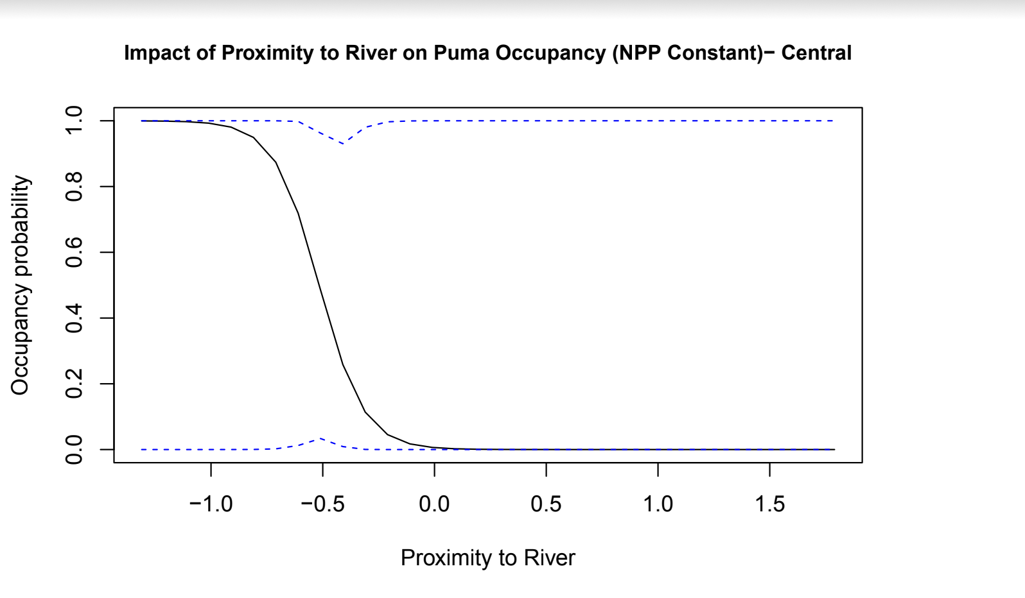

*Figure 1: The relationship between pumas and the proximity to rivers (in meters). The blue dotted line represents both the upper and lower limits of the margins of error.*

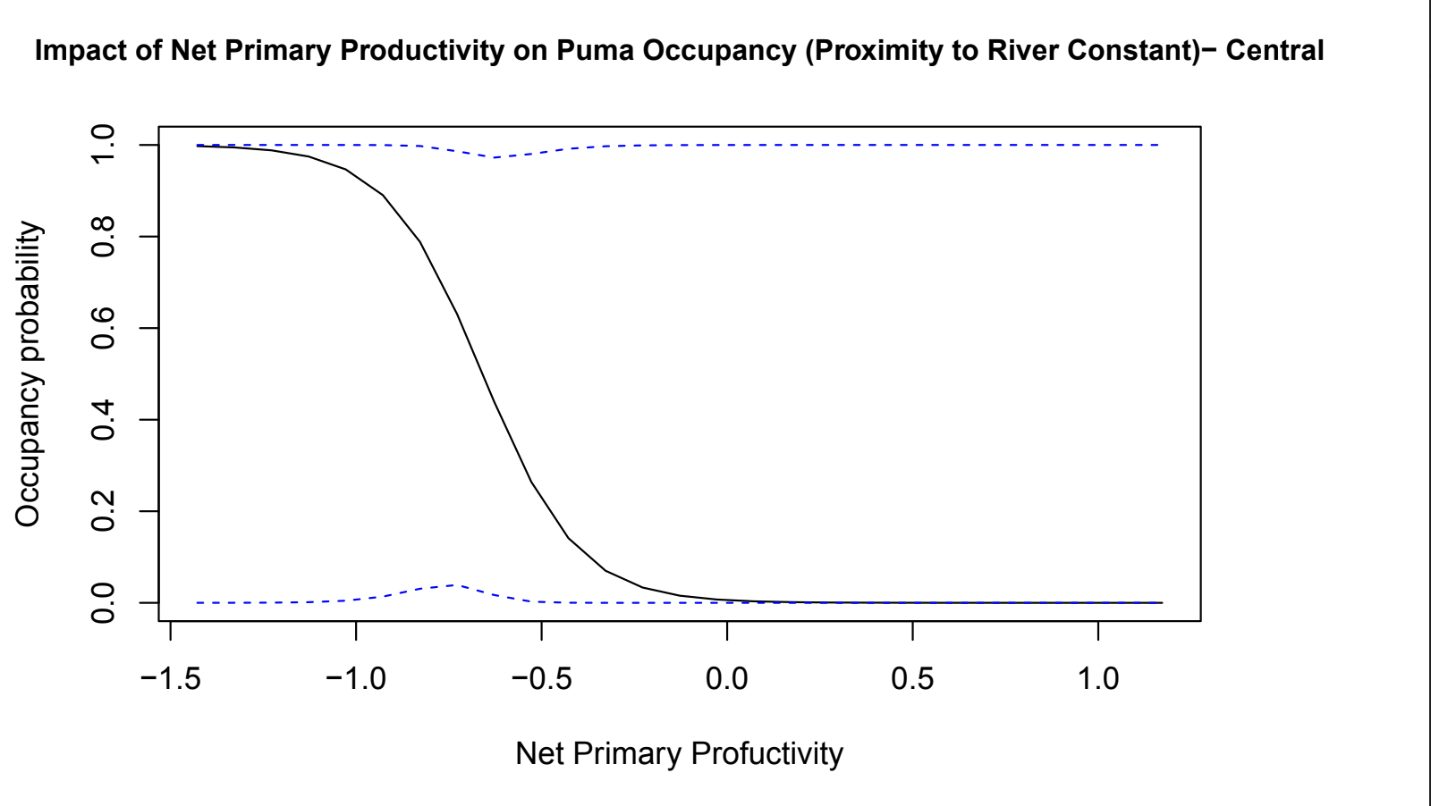

*Figure 2: The relationship between pumas and net primary productivity. The blue dotted line represents both the upper and lower limits of the margins of error.*